Jun 21, 2023
Graphic modelling contest
How to engage young forces in an elaboration process that also requires inventiveness? Our partners at Universidad de Sevilla have organized a contest, among undergraduate students of Computer Science, to do a Graphics Modelling project inspired in our project REXASI-PRO. So, the Consortium decided to launch a small challenge on Twitter. Students created some 3D images and we collected the best results in three groups. The ones that received more Likes (until June 15th, 2023) are posted here.
The input given by the students may be considered a useful contribution to the Consortium as the project progresses. It will stimulate a discussion of ideas on the graphic details through which to present the technological solution, starting with the perception of the physical environments within which REXASI-PRO will operate.
Congratulations to all the participants!

GROUP 1 – Authors: Maria Barrancos Marquez, Jaime Caballero Hernandez, Pablo Pino Mateo
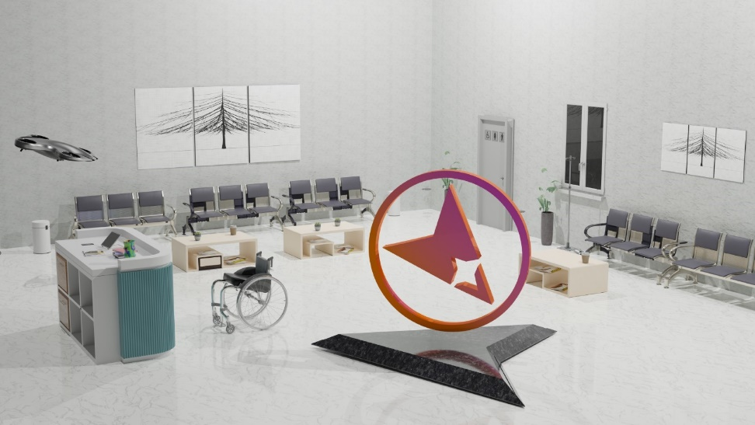
GROUP 2 - Authors: Laura Roldán Merat, Pedro Jesus Ruiz Aguilar, Ismael Ruiz Jurado
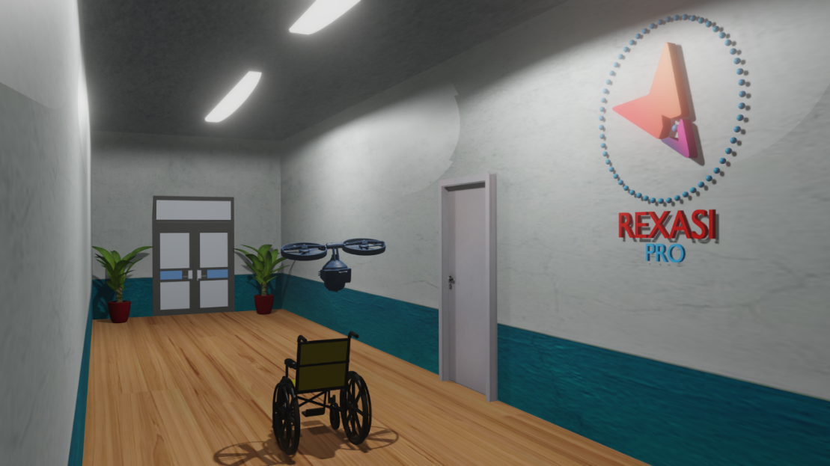
GROUP 3 - Authors: María Márquez Soldán, Olegario Morato Navarro
